An Introduction to Cloud Composer 2.5

## Overview

Workflows are a common theme in data analytics - they involve ingesting, transforming, and analyzing data to figure out the meaningful information within. In Google Cloud Platform (GCP), the tool for hosting workflows is Cloud Composer which is a hosted version of the popular open source workflow tool Apache Airflow.

In this lab, you use the GCP Console to set up a Cloud Composer environment. You then use Cloud Composer to go through a simple workflow that verifies the existence of a data file, creates a Cloud Dataproc cluster, runs an Apache Hadoop wordcount job on the Cloud Dataproc cluster, and deletes the Cloud Dataproc cluster afterwards.

### **What you'll do**

* Use GCP Console to create the Cloud Composer environment
* View and run the DAG (Directed Acyclic Graph) in the Airflow web interface
* View the results of the wordcount job in storage.

### **Activate Google Cloud Shell**

Google Cloud Shell is a virtual machine that is loaded with development tools. It offers a persistent 5GB home directory and runs on the Google Cloud. Google Cloud Shell provides command-line access to your GCP resources.

1. In GCP console, on the top right toolbar, click the Open Cloud Shell button.

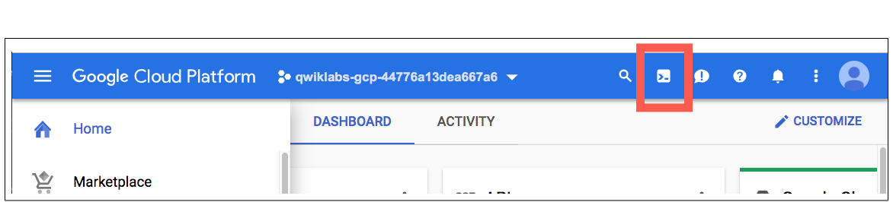

1. Click **Continue**. 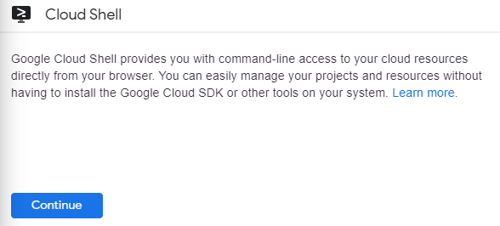

It takes a few moments to provision and connect to the environment. When you are connected, you are already authenticated, and the project is set to your PROJECT_ID. For example:

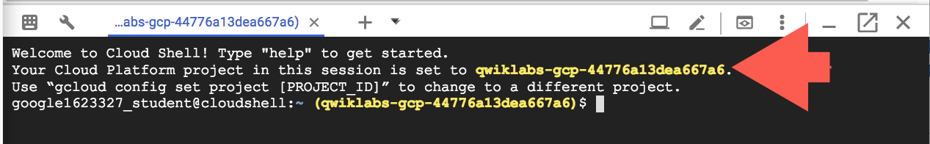

**gcloud** is the command-line tool for Google Cloud Platform. It comes pre-installed on Cloud Shell and supports tab-completion.

You can list the active account name with this command:

gcloud auth list

Copied!

content_copy

Output:

Credentialed accounts:

- <myaccount>@<mydomain>.com (active)

Example output:

Credentialed accounts:

- google1623327_student@qwiklabs.net

You can list the project ID with this command:

gcloud config list project

Copied!

content_copy

Output:

[core]

project = <project_ID>

Example output:

[core]

project = qwiklabs-gcp-44776a13dea667a6

Full documentation of **gcloud** is available on [Google Cloud gcloud Overview](https://cloud.google.com/sdk/gcloud).

### **Check project permissions**

Before you begin your work on Google Cloud, you need to ensure that your project has the correct permissions within Identity and Access Management (IAM).

1. In the Google Cloud console, on the **Navigation menu** (Navigation menu icon), click **IAM & Admin** > **IAM**.
2. Confirm that the default compute Service Account {project-number}-compute@developer.gserviceaccount.com is present and has the editor role assigned. The account prefix is the project number, which you can find on **Navigation menu** > **Home**.

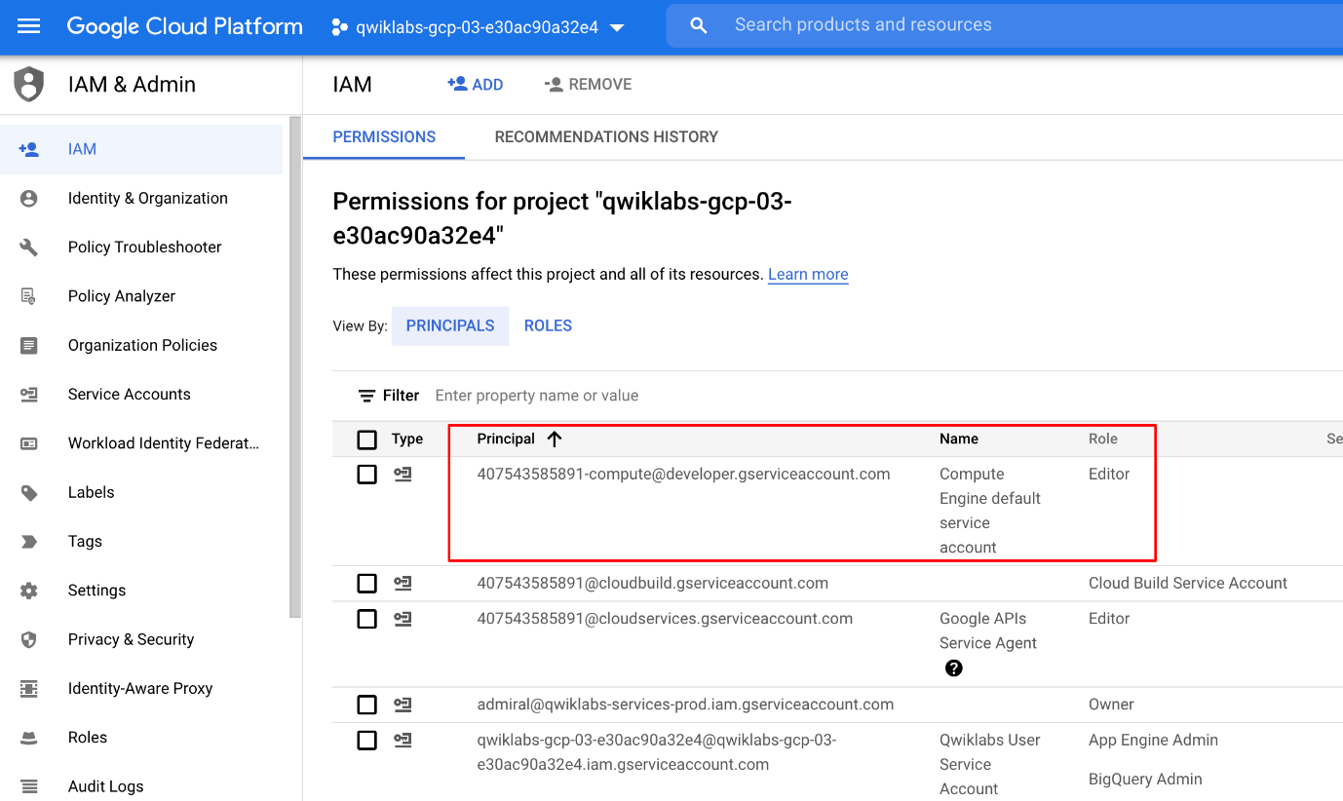

If the account is not present in IAM or does not have the editor role, follow the steps below to assign the required role.

* In the Google Cloud console, on the **Navigation menu**, click **Home**.
* Copy the project number (e.g. 729328892908).
* On the **Navigation menu**, click **IAM & Admin** > **IAM**.
* At the top of the **IAM** page, click **Add**.
* For **New principals**, type:

{project-number}-compute@developer.gserviceaccount.com

Copied!

content_copy

Replace {project-number} with your project number.

* For **Role**, select **Project** (or Basic) > **Editor**. Click **Save**.

## Ensure that the Kubernetes Engine API is successfully enabled

To ensure access to the necessary APIs, restart the connection to the Kubernetes Engine API.

1. In the Google Cloud Console, enter **Kubernetes Engine API** in the top search bar. Click on the result for **Kubernetes Engine API**.
2. Click **Manage**.
3. Click **Disable API**.

If asked to confirm, click **Disable**.

Again, when prompted Do you want to disable Kubernetes Engine API and its dependent APIs?, Click **Disable**.

1. Click **Enable**.

When the API has been enabled again, the page will show the option to disable.

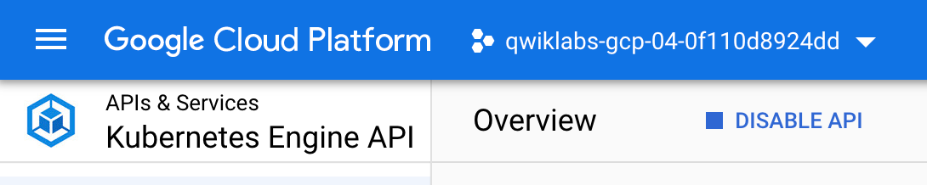

## Ensure that the Cloud Composer API is successfully enabled

Restart the connection to the Cloud Composer API. In the prior step, restarting the Kubernetes Engine API forced the Cloud Composer API to be disabled.

1. In the Google Cloud Console, enter **Cloud Composer API** in the top search bar. Click on the result for **Cloud Composer API**.
2. Click **Enable**.

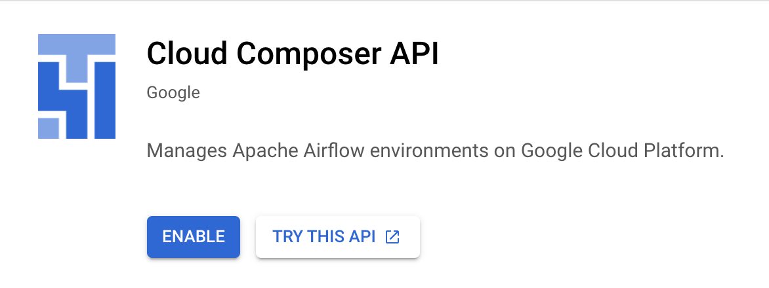

When the API has been enabled again, the page will show the option to disable.

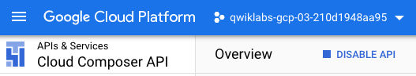

## Create Cloud Composer environment

In this section, you create a Cloud Composer environment.

Before proceeding further, make sure that you have performed earlier tasks to ensure that the required APIs are successfully enabled. If not, then please perform those tasks otherwise Cloud Composer environment creation will fail.

1. Go to **Navigation menu** > **Composer**:

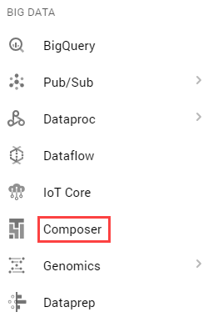

1. Click **CREATE ENVIRONMENT** and select **Composer 1**. Set the following for your environment:

|  |  |
| --- | --- |
| **Property** | **Value** |
| **Name** | highcpu |
| **Location** | us-central1 |
| **Zone** | us-central1-a |
| **Machine type** | n1-highcpu-4 |

Leave all other settings as default.

1. Click **Create**.

The environment creation process is completed when the green checkmark displays to the left of the environment name on the Environments page in the GCP Console.

It can take 10-20 minutes for the environment to complete the setup process. Continue with the lab while the environment spins up.

Click **Check my progress** to verify the objective.

Create Cloud Composer environment.

Check my progress

### **Create a Cloud Storage bucket**

Create a Cloud Storage bucket in your project. This buckets will be used as output for the Hadoop job from Dataproc.

1. Go to **Navigation menu** > **Cloud Storage** > **Browser** and then click **Create bucket**.
2. Give your bucket a universally unique name, then click **Create**.

Remember the Cloud Storage bucket name as you'll use it as an Airflow variable later in the lab.

Click **Check my progress** to verify the objective.

Create a Cloud Storage bucket.

Check my progress

## Airflow and core concepts

While waiting for your Composer environment to get created, review some terms that are used with Airflow.

[Airflow](https://airflow.apache.org/) is a platform to programmatically author, schedule and monitor workflows.

Use Airflow to author workflows as directed acyclic graphs (DAGs) of tasks. The airflow scheduler executes your tasks on an array of workers while following the specified dependencies.

### **Core concepts**

[DAG](https://airflow.apache.org/docs/apache-airflow/stable/concepts/dags.html)

A Directed Acyclic Graph is a collection of all the tasks you want to run, organized in a way that reflects their relationships and dependencies.

[Operator](https://airflow.apache.org/docs/apache-airflow/stable/concepts/operators.html)

The description of a single task, it is usually atomic. For example, the BashOperator is used to execute bash command.

[Task](https://airflow.apache.org/docs/apache-airflow/stable/concepts/tasks.html)

A parameterised instance of an Operator; a node in the DAG.

[Task Instance](https://airflow.apache.org/docs/apache-airflow/stable/concepts/tasks.html#task-instances)

A specific run of a task; characterized as: a DAG, a Task, and a point in time. It has an indicative state: running, success, failed, skipped, ...

You can read more about the concepts [here](https://airflow.apache.org/concepts.html).

## Defining the workflow

Now let's discuss the workflow you'll be using. Cloud Composer workflows are comprised of [DAGs (Directed Acyclic Graphs)](https://airflow.apache.org/docs/apache-airflow/stable/concepts/dags.html). DAGs are defined in standard Python files that are placed in Airflow's DAG_FOLDER. Airflow will execute the code in each file to dynamically build the DAG objects. You can have as many DAGs as you want, each describing an arbitrary number of tasks. In general, each one should correspond to a single logical workflow.

Below is the hadoop_tutorial.py workflow code, also referred to as the DAG:

"""Example Airflow DAG that creates a Cloud Dataproc cluster, runs the Hadoop

wordcount example, and deletes the cluster.

This DAG relies on three Airflow variables

https://airflow.apache.org/concepts.html#variables

* gcp_project - Google Cloud Project to use for the Cloud Dataproc cluster.

* gce_zone - Google Compute Engine zone where Cloud Dataproc cluster should be

created.

* gcs_bucket - Google Cloud Storage bucket to used as output for the Hadoop jobs from Dataproc.

See https://cloud.google.com/storage/docs/creating-buckets for creating a

bucket.

"""

import datetime

import os

from airflow import models

from airflow.contrib.operators import dataproc_operator

from airflow.utils import trigger_rule

# Output file for Cloud Dataproc job.

output_file = os.path.join(

models.Variable.get('gcs_bucket'), 'wordcount',

datetime.datetime.now().strftime('%Y%m%d-%H%M%S')) + os.sep

# Path to Hadoop wordcount example available on every Dataproc cluster.

WORDCOUNT_JAR = (

'file:///usr/lib/hadoop-mapreduce/hadoop-mapreduce-examples.jar'

)

# Arguments to pass to Cloud Dataproc job.

wordcount_args = ['wordcount', 'gs://pub/shakespeare/rose.txt', output_file]

yesterday = datetime.datetime.combine(

datetime.datetime.today() - datetime.timedelta(1),

datetime.datetime.min.time())

default_dag_args = {

# Setting start date as yesterday starts the DAG immediately when it is

# detected in the Cloud Storage bucket.

'start_date': yesterday,

# To email on failure or retry set 'email' arg to your email and enable

# emailing here.

'email_on_failure': False,

'email_on_retry': False,

# If a task fails, retry it once after waiting at least 5 minutes

'retries': 1,

'retry_delay': datetime.timedelta(minutes=5),

'project_id': models.Variable.get('gcp_project')

}

with models.DAG(

'composer_sample_quickstart',

# Continue to run DAG once per day

schedule_interval=datetime.timedelta(days=1),

default_args=default_dag_args) as dag:

# Create a Cloud Dataproc cluster.

create_dataproc_cluster = dataproc_operator.DataprocClusterCreateOperator(

task_id='create_dataproc_cluster',

# Give the cluster a unique name by appending the date scheduled.

# See https://airflow.apache.org/code.html#default-variables

cluster_name='composer-hadoop-tutorial-cluster-{{ ds_nodash }}',

num_workers=2,

region='us-central1',

zone=models.Variable.get('gce_zone'),

image_version='2.0',

master_machine_type='n1-standard-2',

worker_machine_type='n1-standard-2')

# Run the Hadoop wordcount example installed on the Cloud Dataproc cluster

# master node.

run_dataproc_hadoop = dataproc_operator.DataProcHadoopOperator(

task_id='run_dataproc_hadoop',

region='us-central1',

main_jar=WORDCOUNT_JAR,

cluster_name='composer-hadoop-tutorial-cluster-{{ ds_nodash }}',

arguments=wordcount_args)

# Delete Cloud Dataproc cluster.

delete_dataproc_cluster = dataproc_operator.DataprocClusterDeleteOperator(

task_id='delete_dataproc_cluster',

region='us-central1',

cluster_name='composer-hadoop-tutorial-cluster-{{ ds_nodash }}',

# Setting trigger_rule to ALL_DONE causes the cluster to be deleted

# even if the Dataproc job fails.

trigger_rule=trigger_rule.TriggerRule.ALL_DONE)

# Define DAG dependencies.

create_dataproc_cluster >> run_dataproc_hadoop >> delete_dataproc_cluster

To orchestrate the three workflow tasks, the DAG imports the following operators:

1. DataprocClusterCreateOperator: Creates a Cloud Dataproc cluster.
2. DataProcHadoopOperator: Submits a Hadoop wordcount job and writes results to a Cloud Storage bucket.
3. DataprocClusterDeleteOperator: Deletes the cluster to avoid incurring ongoing Compute Engine charges.

The tasks run sequentially, which you can see in this section of the file:

# Define DAG dependencies.

create_dataproc_cluster >> run_dataproc_hadoop >> delete_dataproc_cluster

The name of the DAG is quickstart, and the DAG runs once each day.

with models.DAG(

'composer_sample_quickstart',

# Continue to run DAG once per day

schedule_interval=datetime.timedelta(days=1),

default_args=default_dag_args) as dag:

Because the start_date that is passed in to default_dag_args is set to yesterday, Cloud Composer schedules the workflow to start immediately after the DAG uploads.

## Viewing environment information

1. Go back to **Composer** to check the status of your environment.
2. Once your environment has been created, click the name of the environment (highcpu) to see its details.

On the **Environment details** you'll see information such as the Airflow web interface URL, Kubernetes Engine cluster ID, and a link to the DAGs folder, which is stored in your bucket.

**Note:** Cloud Composer only schedules the workflows in the /dags folder.

## Using the Airflow UI

To access the Airflow web interface using the GCP Console:

1. Go back to the **Environments** page.
2. In the **Airflow webserver** column for the environment, click **Airflow**.
3. Click on your lab credentials.
4. The Airflow web interface opens in a new browser window.

## Setting Airflow variables

Airflow variables are an Airflow-specific concept that is distinct from [environment variables](https://cloud.google.com/composer/docs/how-to/managing/environment-variables).

1. Select **Admin** > **Variables** from the Airflow menu bar, then **Create**.

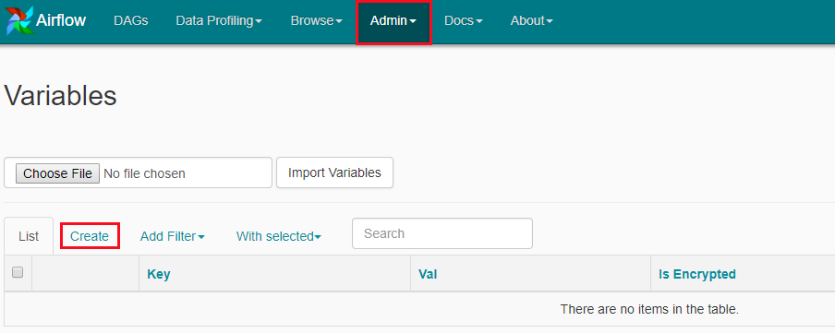

1. Create the following Airflow variables, gcp_project, gcs_bucket, and gce_zone:

|  |  |  |
| --- | --- | --- |
| **KEY** | **VALUE** | **Details** |
| gcp_project | <your project-id> | The Google Cloud Platform project you're using for this quickstart. |
| gcs_bucket | gs://<my-bucket> | Replace <my-bucket> with the name of the Cloud Storage bucket you made earlier. This bucket stores the output from the Hadoop jobs from Dataproc. |
| gce_zone | us-central1-a | This is the Compute Engine zone where your Cloud Dataproc cluster will be created. To chose a different zone, see [Available regions & zones.](https://cloud.google.com/compute/docs/regions-zones/regions-zones#available) |

Click **Save and Add Another** after adding first two variable and click **Save** for the third variable. Your Variables table should look like this when you're finished:

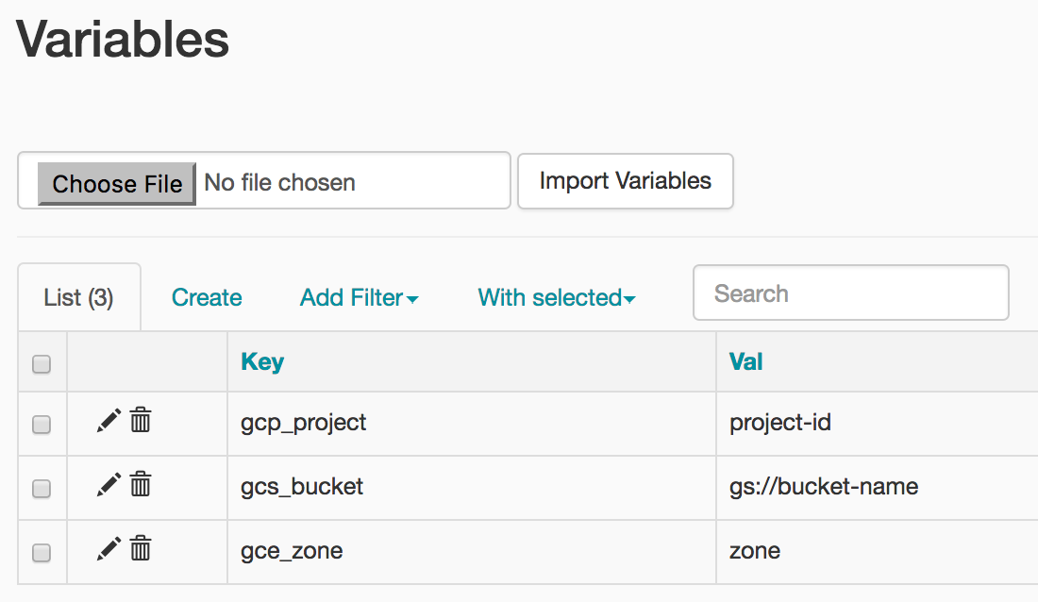

## Uploading the DAG to Cloud Storage

To upload the DAG:

1. In Cloud Shell, upload a copy of the hadoop_tutorial.py file to the Cloud Storage bucket that was automatically created when you created the environment.

Replace <DAGs_folder_path> in the following command:

gsutil cp gs://cloud-training/datawarehousing/lab_assets/hadoop_tutorial.py <DAGs_folder_path>

Copied!

content_copy

with the path to the DAGs folder. You can get the path by going to **Composer**. Click on the environment you created earlier and then click on the **Environment Configuration** tab to see the details of the environment. Find DAGs folder and copy the path.

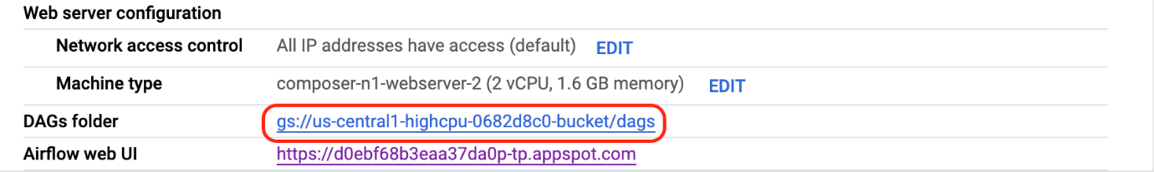

The revised command to upload the file will look similar to the one below:

gsutil cp gs://cloud-training/datawarehousing/lab_assets/hadoop_tutorial.py gs://us-central1-highcpu-0682d8c0-bucket/dags

Once the file has been successfully uploaded to the DAGs directory, open dags folder in the bucket and you will see the file in the **Objects** tab of the Bucket details.

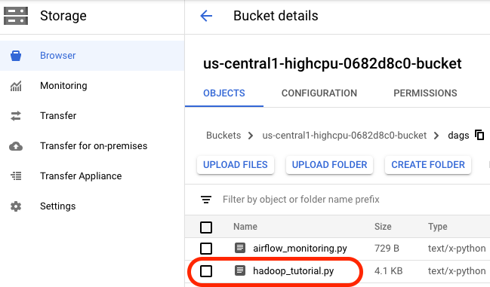

When a DAG file is added to the DAGs folder, Cloud Composer adds the DAG to Airflow and schedules it automatically. DAG changes occur within 3-5 minutes.

You can see the task status of the composer_hadoop_tutorial DAG in the Airflow web interface.

Click **Check my progress** to verify the objective.

Uploading the DAG to Cloud Storage.

Check my progress

### **Exploring DAG runs**

When you upload your DAG file to the dags folder in Cloud Storage, Cloud Composer parses the file. If no errors are found, the name of the workflow appears in the DAG listing, and the workflow is queued to run immediately.

Make sure that you're on the DAGs tab in the Airflow web interface. It takes several minutes for this process to complete. Refresh your browser to make sure you're looking at the latest information.

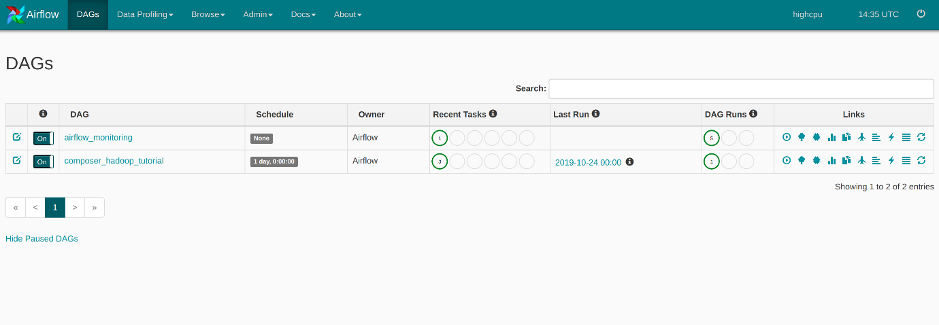

1. In Airflow, click **composer_hadoop_tutorial** to open the DAG details page. This page includes several representations of the workflow tasks and dependencies.

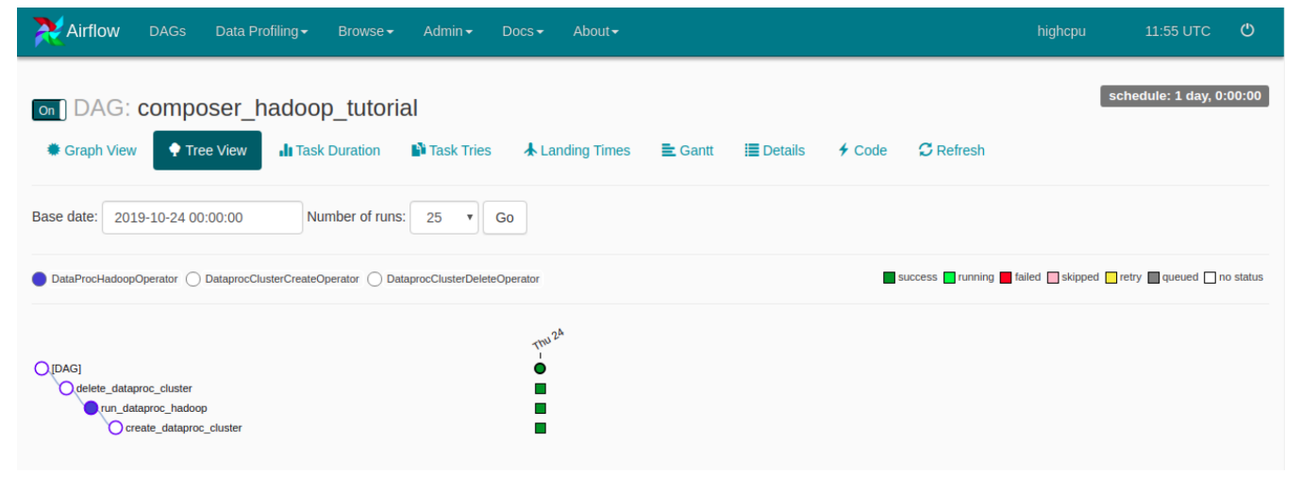

1. In the toolbar, click **Graph View**. Mouseover the graphic for each task to see its status. Note that the border around each task also indicates the status (green border = running; red = failed, etc.).

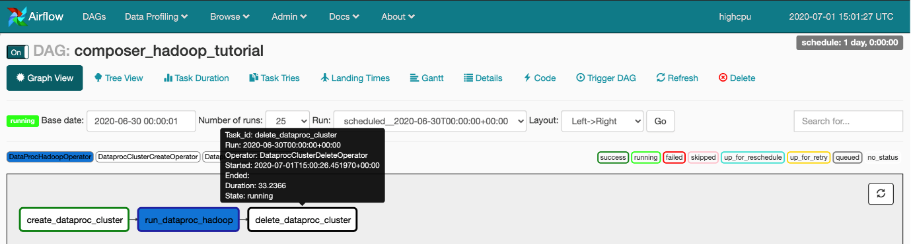

1. Click the "Refresh" link to make sure you're looking at the most recent information. The borders of the processes change colors as the state of the process changes

Note: If your Dataproc cluster already exists, you can run the workflow again to reach the success state by clicking create_dataproc_cluster graphic and then click **Clear** to reset the three tasks and click **OK** to confirm.

1. Once the status for **create_dataproc_cluster** has changed to "running", go to **Navigation menu** > **Dataproc**, then click on:

* **Clusters** to monitor cluster creation and deletion. The cluster created by the workflow is ephemeral: it only exists for the duration of the workflow and is deleted as part of the last workflow task.
* **Jobs** to monitor the Apache Hadoop wordcount job. Click the Job ID to see job log output.

1. Once Dataproc gets to a state of "Running", return to Airflow and click **Refresh** to see that the cluster is complete.

When the run_dataproc_hadoop process is complete, go to **Navigation menu** > **Cloud Storage** > **Browser** and click on the name of your bucket to see the results of the wordcount in the wordcount folder.

1. Once all the steps are complete in the DAG, each step has a dark green border. Additionally the Dataproc cluster that was created is now deleted.

## Congratulations!

You've successfully run a Cloud Composer workflow!

## Next steps

* Check out when Cloud Composer was presented at NEXT 18 in San Francisco: <https://www.youtube.com/watch?v=GeNFEtt-D4k>
* To see the value of a variable, run the Airflow CLI sub-command [variables](https://airflow.apache.org/docs/apache-airflow/stable/cli-and-env-variables-ref.html#variables) with the get argument or use the [Airflow web interface](https://cloud.google.com/composer/docs/quickstart#variables-ui).
* For information about the Airflow web interface, see [Accessing the web interface](https://cloud.google.com/composer/docs/how-to/accessing/airflow-web-interface#accessing_the_web_interface).

## End your lab